PRACTICAL NO – 1

WRITE A MONGODB QUERY TO CREATE, DISPLAY AND DROP A DATABASE.

  - CREATE DATABASE
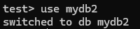

DISPLAY DATABASE
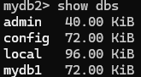

DROP DATABASE
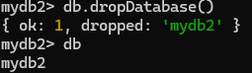

WRITE A MONGODB QUERY TO CREATE, DISPLAY AND DROP A COLLECTION.

  - CREATE COLLECTION
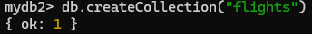

DISPLAY COLLECTION
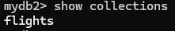

DROP COLLECTION
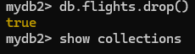

WRITE A MONGODB QUERY TO INSERT A DOCUMENT INTO THE

COLLECTION (insertOne , insertMany).

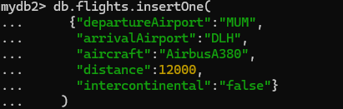
INSERT ONE CODE:

OUTPUT:
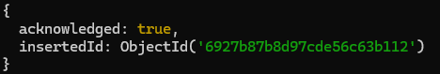

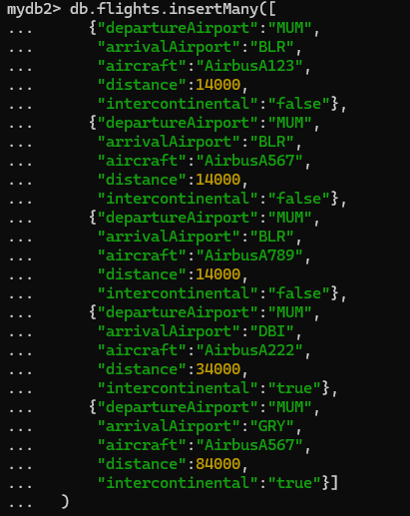
INSERT MANY CODE:

OUTPUT:
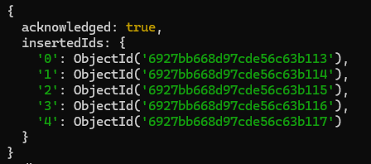

WRITE A MONGODB QUERY TO RETRIEVE THE DOCUMENTS (find,
findOne).

FIND CODE:
OUTPUT:
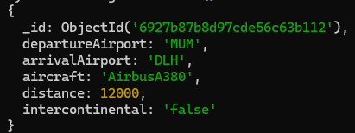

FIND ONE CODE:
OUTPUT:
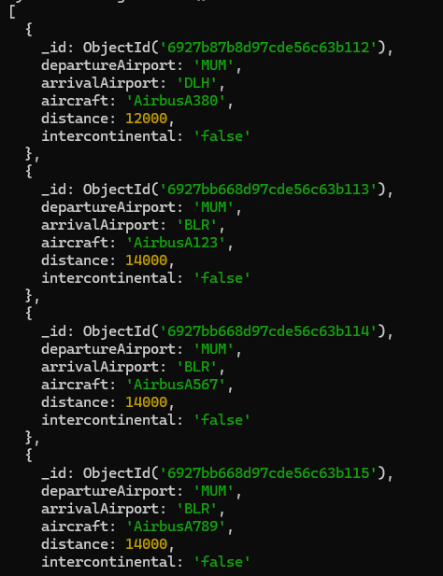
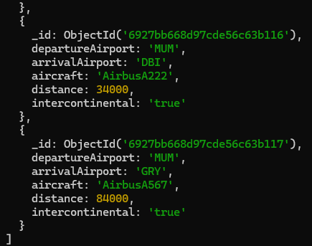

WRITE A MONGODB QUERY TO UPDATE THE DOCUMENTS (updateOne,
updateMany).

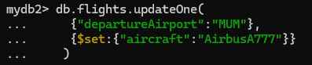
UPDATE ONE CODE:
OUTPUT:
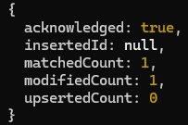
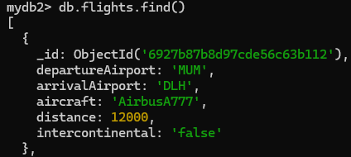

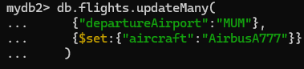
UPDATE MANY CODE:
OUTPUT:
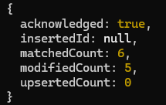
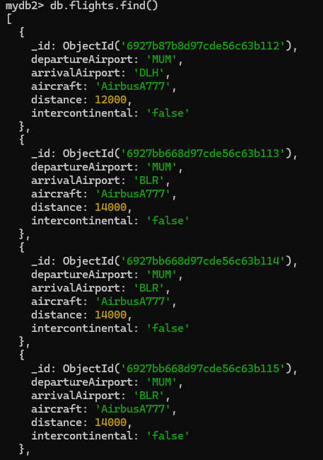
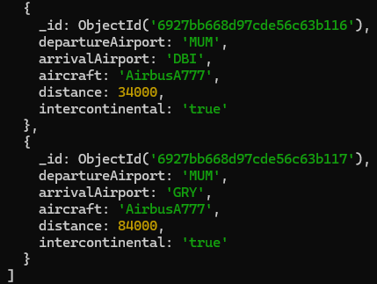

WRITE A MONGODB QUERY TO DELETE THE DOCUMENTS (deleteOne,
deleteMany).

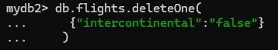
DELETE ONE CODE:
OUTPUT:

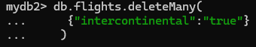
DELETE MANY CODE:
OUTPUT:

PRACTICAL NO – 2

Create a collection users and insert documents into it (as per the files attached). CODE:
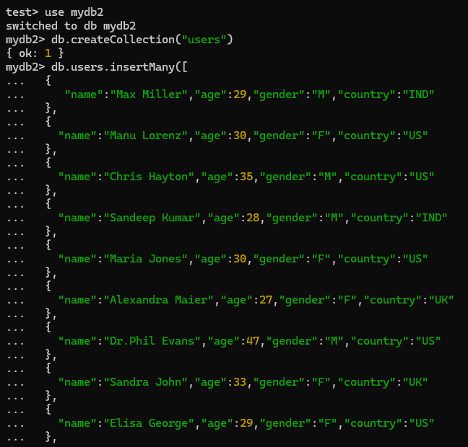
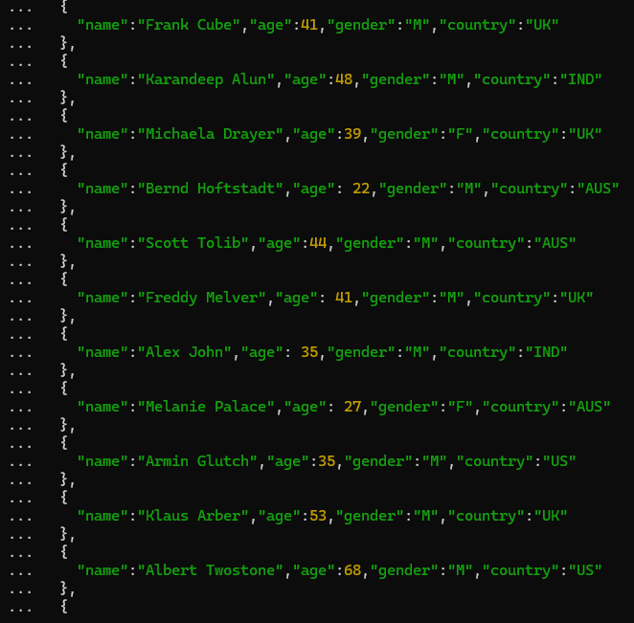

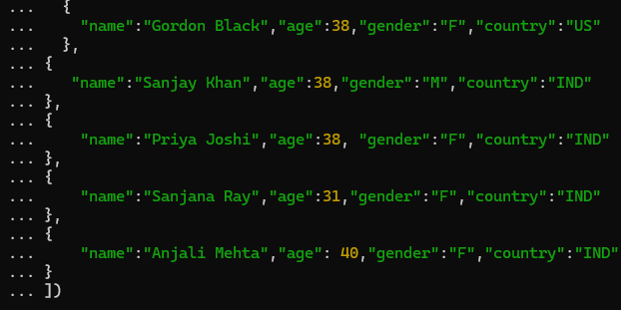

OUTPUT:
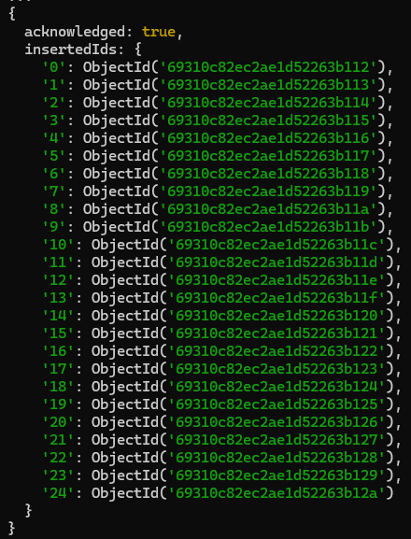

List all the documents in users collection. CODE:

OUTPUT:
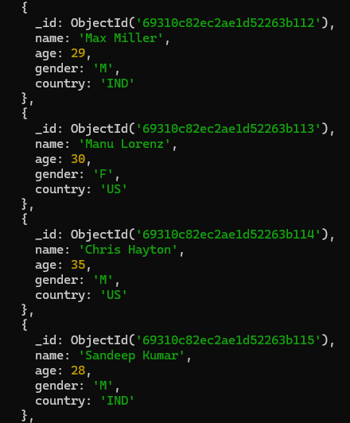
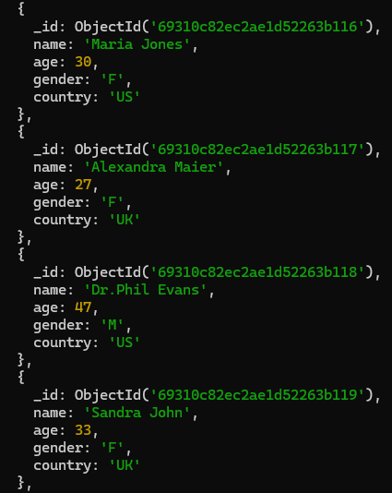

{
_id: Objectid( name:
age: ._,;,
�:• C)
gender: cou.ntry:
} I
{
_id: Objectid( name:
age: Wl I gender: cou.ntry:
} I
{
_id: Objectid( name:
age: w:;I
gender: cou.ntry:
} I
{
_id: Objectid( name:
age: gender: cou.ntry:
} I
{
_id: Objectid( name:
age: ~~, gender: cou.ntry:
} I
) I

) I

) I

) I

) I

{
_id: Objectid( name:
age: 27, gender: cou.ntry:
} I
{
_id: Objectid( name:
age:
"C
_,,J,
gender: cou.ntry:
} I
{
_id: Objectid( name:
age: .�l -�I gender: cou.ntry:
} I
{
_id: Objectid( name:
age: gender: cou.ntry:
) I

) I

) I

) I

llitll for
Type
more

Projectors (Include/Exclude specific fields).
  - Select only the name and age fileds from the users collection. CODE:

OUTPUT:
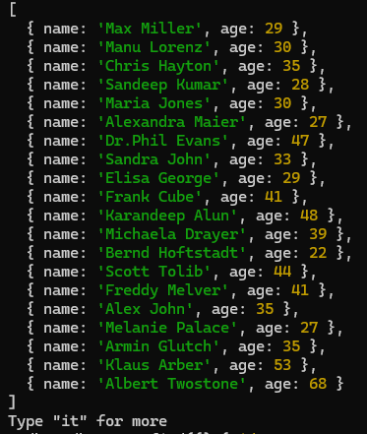

  - Display all the fields in the users collection except, _id, age and gender.

CODE:

OUTPUT:
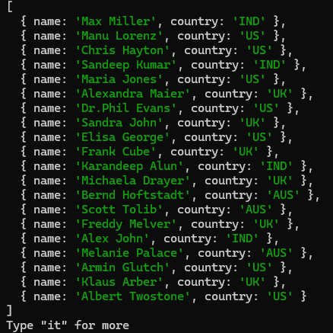

Selectors, AND, OR operations.
  - Fetch all the Indian users from the list. CODE:

OUTPUT:
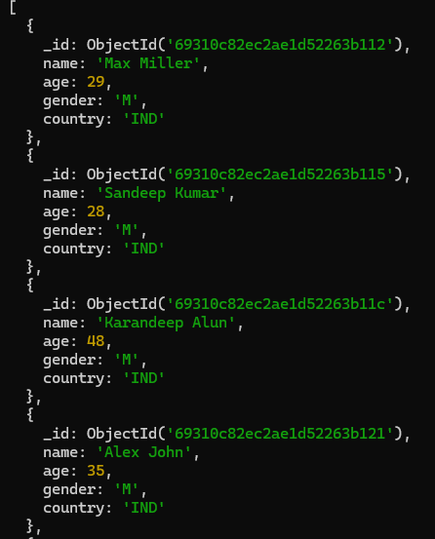
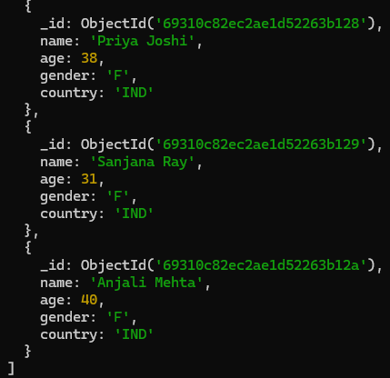

Fetch all the female users from US. CODE:

OUTPUT:
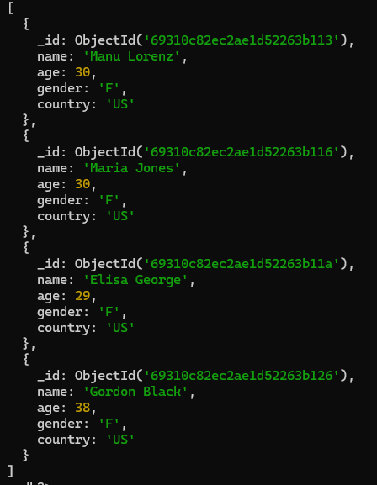

Fetch all the Indian and US users from the list. CODE:

OUTPUT:
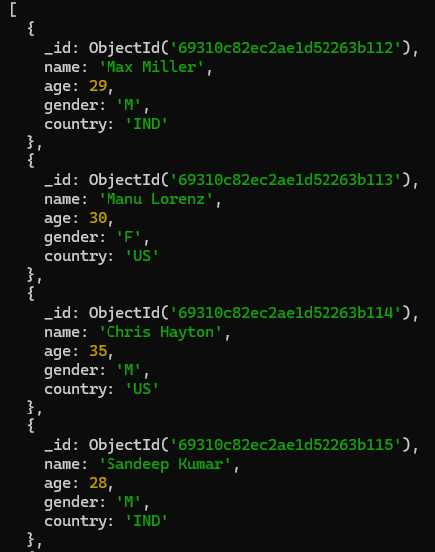
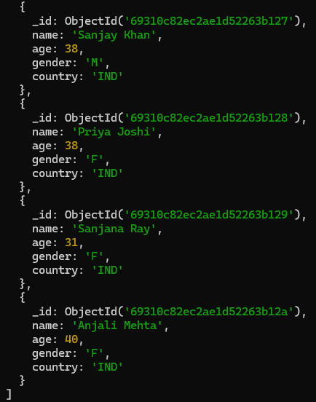

  - Fetch all the US users with age=30 from the list. CODE:

OUTPUT:
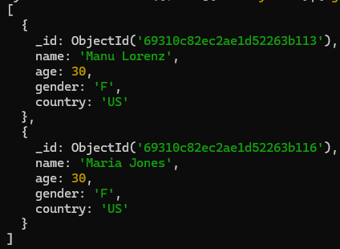

Combining Selectors and Projectors.
  - Display only name, age & country of Indian Users. CODE:

OUTPUT:
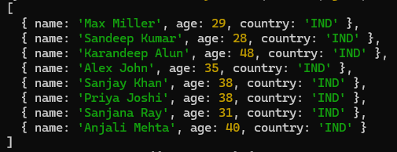

Fetch the name and country of all male users. CODE:

OUTPUT:
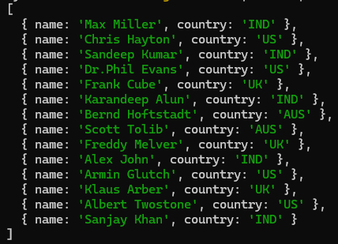

Sort(), limit(), skip(), count().
  - Fetch the name and age of all male users in ascending order of age. CODE:

OUTPUT:
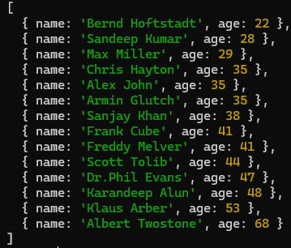

  - Fetch the name and age of all male users in descending order of name and ascending order of age.

CODE:

OUTPUT:
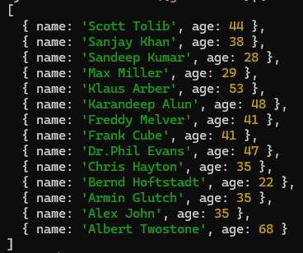

Fetch the first 5 male users CODE:

OUTPUT:
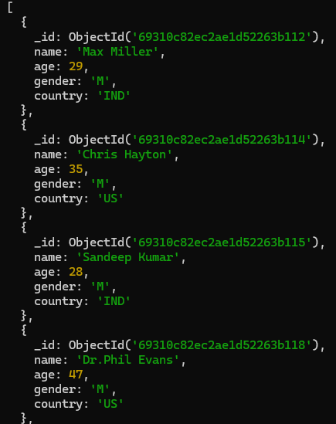
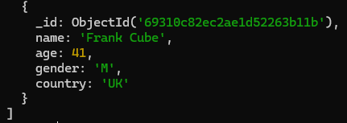

  - Fetch the male users from India. Skip the first two records and list the next three records.

CODE:

OUTPUT:
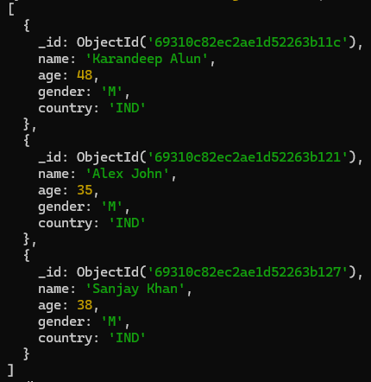

  - Fetch the male users from India. Skip the first two records CODE:

OUTPUT:
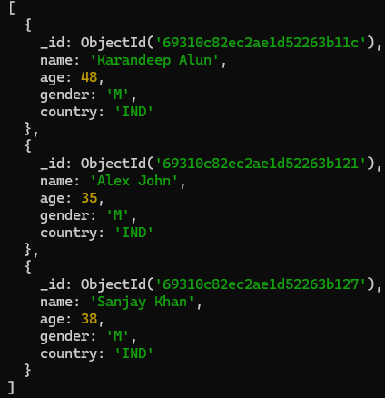

Count the total number of users CODE:

OUTPUT:

  - Count the total number of female users in US CODE:

OUTPUT:

PRACTICAL NO – 3

Using Conditional and Logical Operators AND, OR, NOT. Create the Employees Collection and Insert Documents CODE:
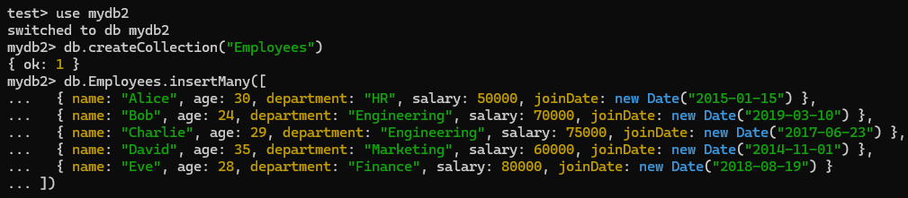

OUTPUT:
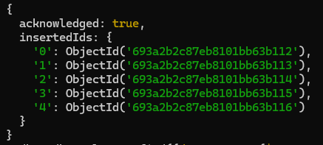

  - Find employees in the “Engineering” department.

CODE:

OUTPUT:
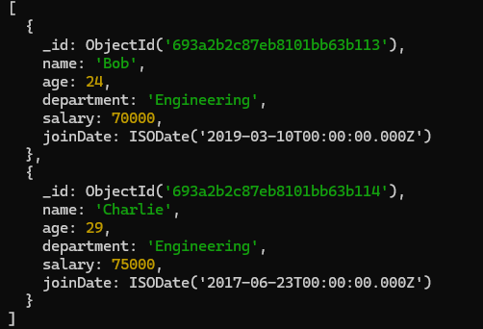

  - Find employees who are not in the “HR” department.

CODE:

OUTPUT:
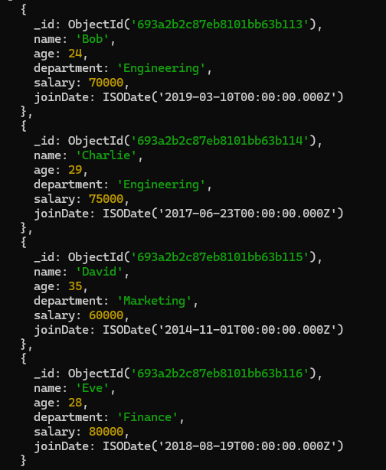

Find employees who are older than 30. CODE:

OUTPUT:
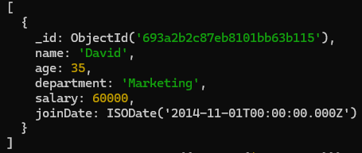

Find employees with a salary less than 70000. CODE:

OUTPUT:
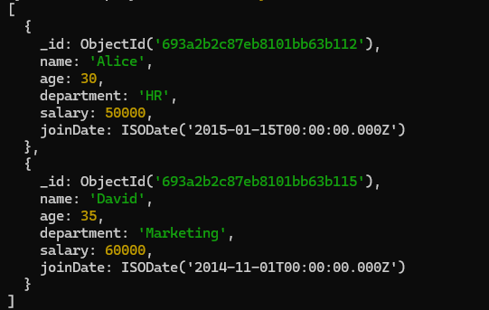

Find employees who joined on or after January 1, 2018 CODE:

OUTPUT:
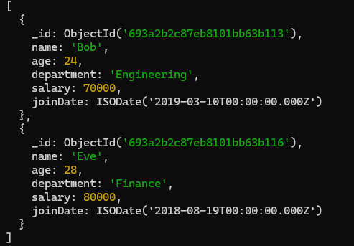

Find employees who are 28 years old or younger. CODE:

OUTPUT:
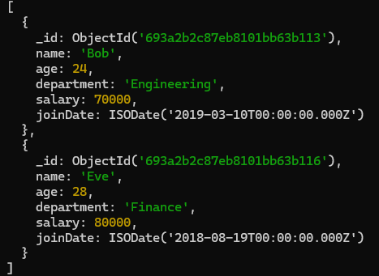

  - $and (Logical AND)
Find employees who are in the “Engineering” department and have a salary greater
than 70000. CODE:

OUTPUT:
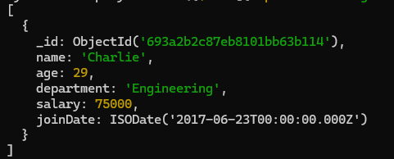

  - $or (Logical OR)
Find employees who are in the “HR” department and have a salary less than 60000.

CODE:

OUTPUT:
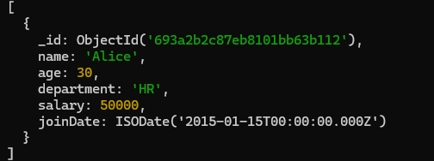

  - $not (Logical NOT)
Find employees who are not in the “Finance” department.

CODE:

OUTPUT:
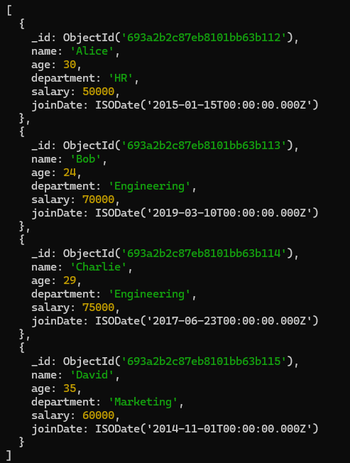

  - $nor (Logical NOR)
Find employees who are neither in the “HR” department nor have a salary greater than

75000. CODE:

OUTPUT:
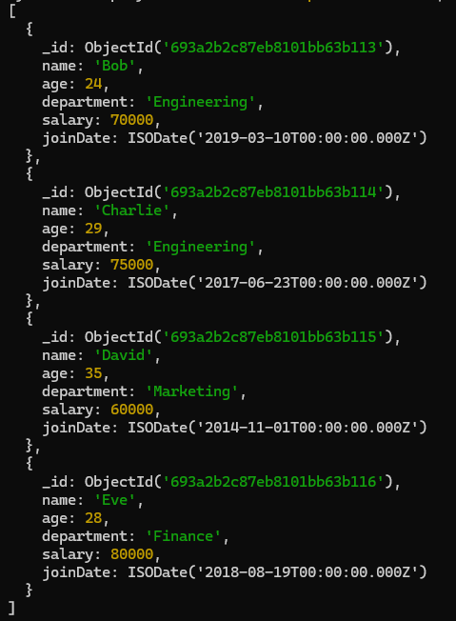

Query Selectors 2b. Bitwise Selectors
$bitsAllClear: Matches documents where all specified bit positions have a value of 0
$bitsAllSet: Matches documents where all specified bit positions have a value of 1
$bitsAnyClear: Matches documents where any of the specified bit positions have a value of 0
$bitsAnySet: Matches documents where any of the specified bit positions have a value of 1

CODE:
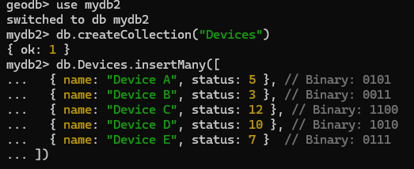

OUTPUT:
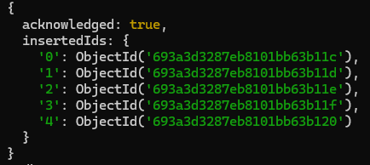

Find devices where the binary status has both the 1st and 3rd bits set CODE:

OUTPUT:
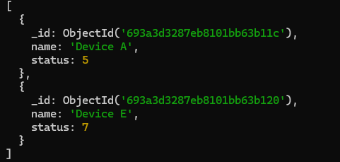

Find devices where the binary status has at least the 2nd bit set CODE:

OUTPUT:
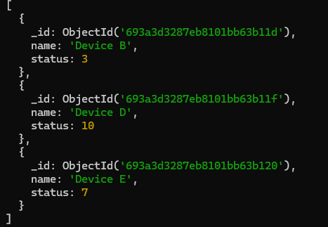

Find devices where the binary status has both the 2nd and 4th bits clear CODE:

OUTPUT:
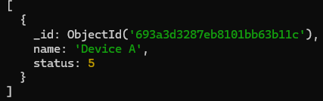

Find devices where the binary status has at least the 1st bit clear CODE:

OUTPUT:
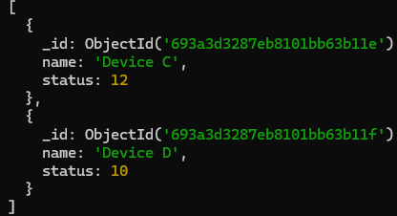

PRACTICAL NO – 4
- Projection Operators ($, $elematch and $slice)

Create the Products Collection and Insert Documents CODE:
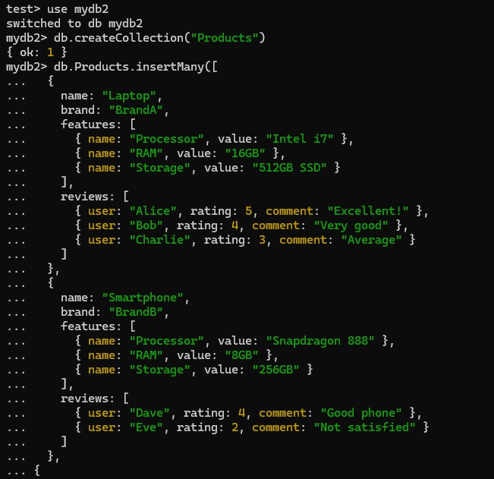
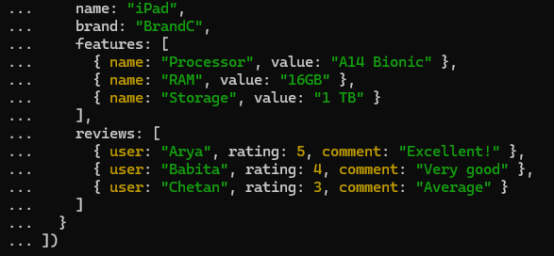

OUTPUT:
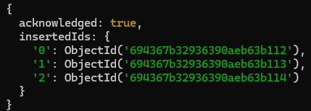

  - Find the product named “Laptop” and project the review from the user “Alice”.

CODE:

OUTPUT:
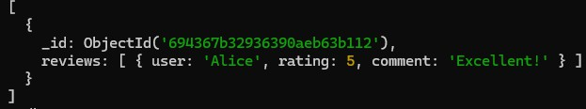

  - Find the product named “Laptop” and project the review where the rating is greater
than 4.

CODE:

OUTPUT:
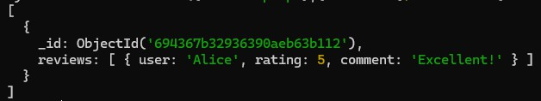

  - Find the product named “Smartphone” and project the first review.

CODE:

OUTPUT:
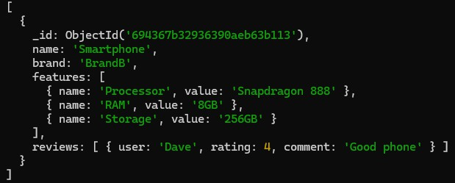

  - Find the product named “Laptop” and project the name, the first two features, and
the review with the highest rating.

CODE:
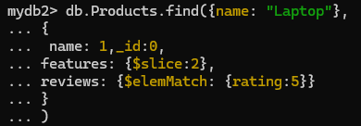

OUTPUT:
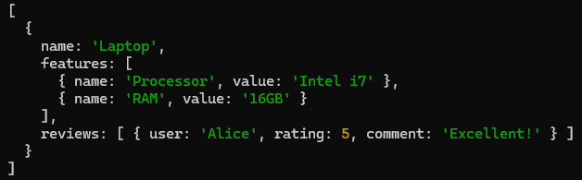

- Aggregation operations such as $sum, $avg, $min, $max, $push, and $addToSet

Create the Products Collection and Insert Documents CODE:
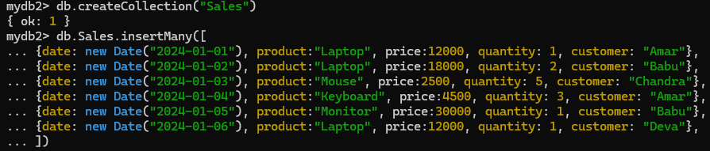

OUTPUT:
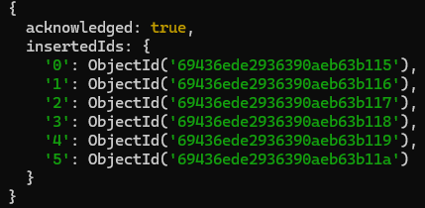

Calculate the total price of each product. CODE:
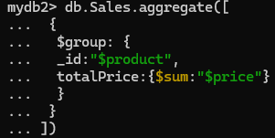

OUTPUT:
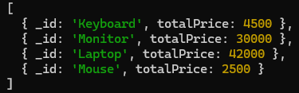

Calculate the average price of each product. CODE:
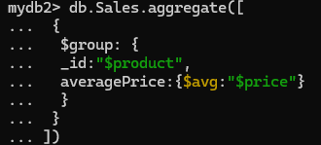

OUTPUT:
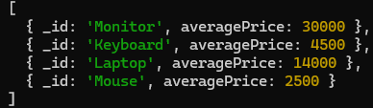

Find the minimum price of each product. CODE:
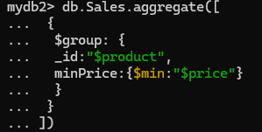

OUTPUT:
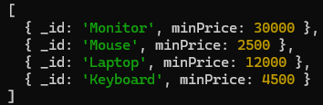

Find the maximum price of each product. CODE:
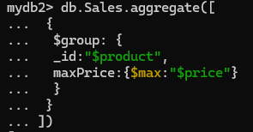

OUTPUT:
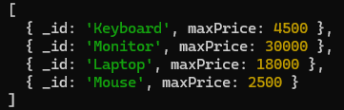

PRACTICAL NO – 5
- Explain() with indexes.
  - Explain() with all three modes for male users in users collection.

CODE:

OUTPUT:
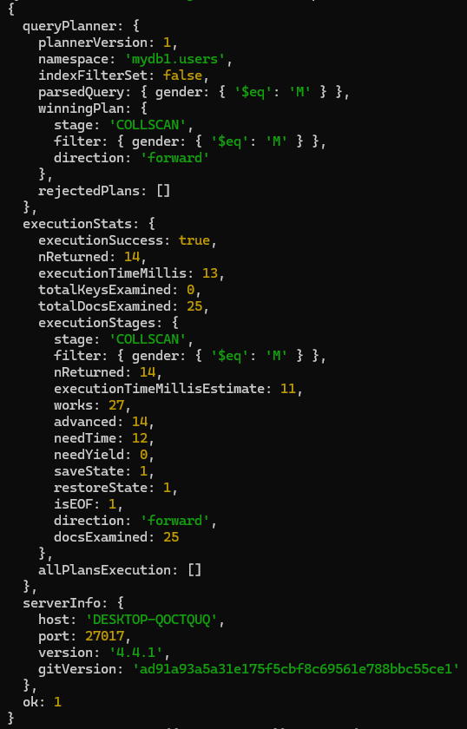

CODE:

OUTPUT:
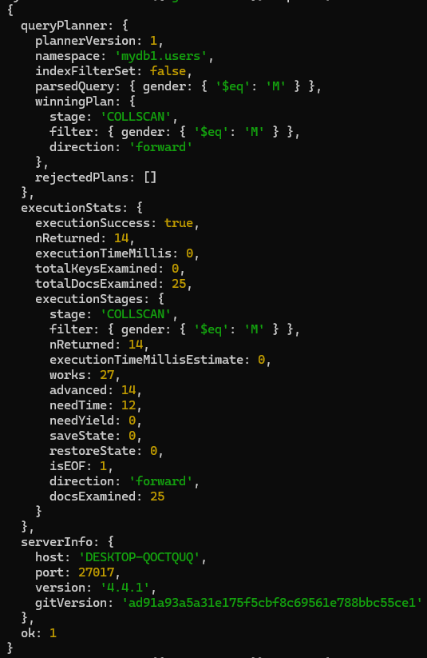

CODE:

OUTPUT:
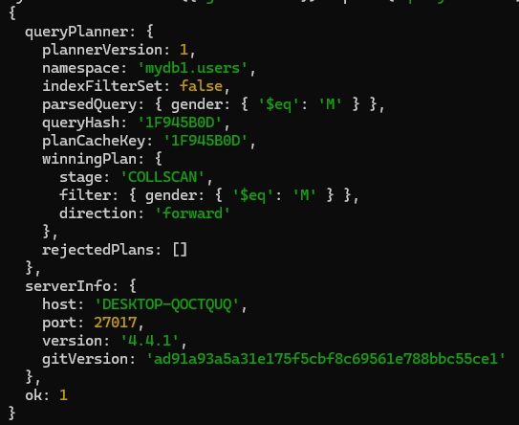

Single Key Index CODE:

OUTPUT:

Compound Key Index CODE:

OUTPUT:

View Index CODE:

OUTPUT:
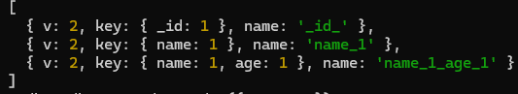

Delete Index CODE:

OUTPUT:

PRACTICAL NO – 6

JQUERY SELECTORS

ELEMENT NAME SELECTOR CODE:
<html>

<head>
<title> The Selector Example</title>
<script type="text/javascript" src="jquery-3.7.1.min.js"></script>

<script type="text/javascript" language="javascript">
$(document).ready(function () {
$("div").css("background-color", "yellow");
});
</script>
</head>

<body>

<div class="big" id="div1">
<p>This is first division of the DOM</p>
</div>

<div class="medium" id="div2">
<p>This is second division of the DOM</p>
</div>

<div class="small" id="div3">
<p>This is third division of the DOM</p>
</div>
</body>

</html>

OUTPUT:
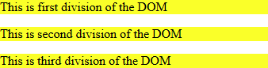

ELEMENT ID SELECTOR CODE:
<html>

<head>
<title> The Selector Example</title>
<script type="text/javascript" src="jquery-3.7.1.min.js"></script>

<script type="text/javascript" language="javascript">
$(document).ready(function () {
$("#div2").css("background-color", "yellow");
});
</script>
</head>

<body>

<div class="big" id="div1">
<p>This is first division of the DOM</p>
</div>

<div class="medium" id="div2">
<p>This is second division of the DOM</p>
</div>

<div class="small" id="div3">
<p>This is third division of the DOM</p>
</div>
</body>

</html>

OUTPUT:
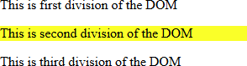

ELEMENT CLASS SELECTOR CODE:
<html>

<head>
<title> The Selector Example</title>
<script type="text/javascript" src="jquery-3.7.1.min.js"></script>

<script type="text/javascript" language="javascript">
$(document).ready(function () {
$(".big").css("background-color", "yellow");
});
</script>
</head>

<body>

<div class="big" id="div1">
<p>This is first division of the DOM</p>
</div>

<div class="medium" id="div2">
<p>This is second division of the DOM</p>
</div>

<div class="small" id="div3">
<p>This is third division of the DOM</p>
</div>
</body>

</html>

OUTPUT:
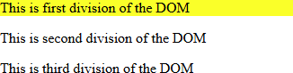

UNIVERSAL SELECTOR CODE:
<html>

<head>
<title> The Selector Example</title>
<script type="text/javascript" src="jquery-3.7.1.min.js"></script>

<script type="text/javascript" language="javascript">
$(document).ready(function () {
$("*").css("background-color", "yellow");
});
</script>
</head>

<body>

<div class="big" id="div1">
<p>This is first division of the DOM</p>
</div>

<div class="medium" id="div2">
<p>This is second division of the DOM</p>
</div>

<div class="small" id="div3">
<p>This is third division of the DOM</p>
</div>
</body>

</html>

OUTPUT:
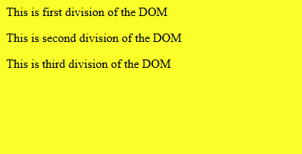

MULTIPLE ELEMENT SELECTOR CODE:
<html>

<head>
<title> The Selector Example</title>
<script type="text/javascript" src="jquery-3.7.1.min.js"></script>

<script type="text/javascript" language="javascript">
$(document).ready(function () {
$(".big, #div3").css("background-color", "yellow");
});
</script>
</head>

<body>

<div class="big" id="div1">
<p>This is first division of the DOM</p>
</div>

<div class="medium" id="div2">
<p>This is second division of the DOM</p>
</div>

<div class="small" id="div3">
<p>This is third division of the DOM</p>
</div>
</body>

</html>

OUTPUT:
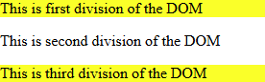

PRACTICAL NO – 7

CLICK EVENT

CODE: (event.html)
<html>
<head>
<title>Click Event</title>
<script type="text/javascript" src="jquery-3.7.1.min.js"></script>
<script type="text/javascript" src="app.js"></script>
<link rel="stylesheet" type="text/css" href="style.css"/>
</head>

<body>
<p>Click on any square below</p>
<div class = "div" style="background-color: blue;">ONE</div>
<div class = "div" style="background-color: green;">TWO</div>
<div class = "div" style="background-color: red;">THREE</div>
</body>
</html>

CODE: (style.css)
.div{
margin:10px; padding:12px; border:2px; width:60px; height:60px;
}

CODE: (app.js)
$(document).ready(function(){
$("div").click(function()
{
alert('Event type is: '+event.type);
alert('The button clicked is: '+event.target.innerHTML);
});
});

OUTPUT:
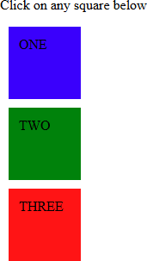
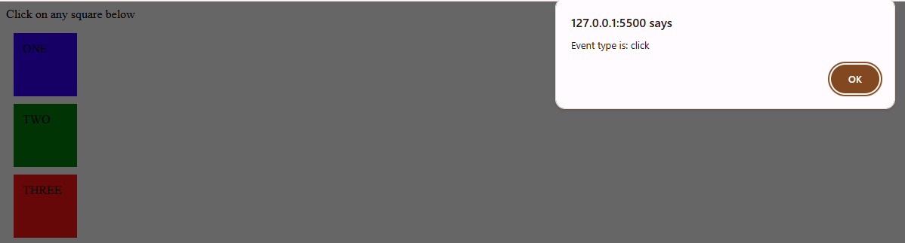
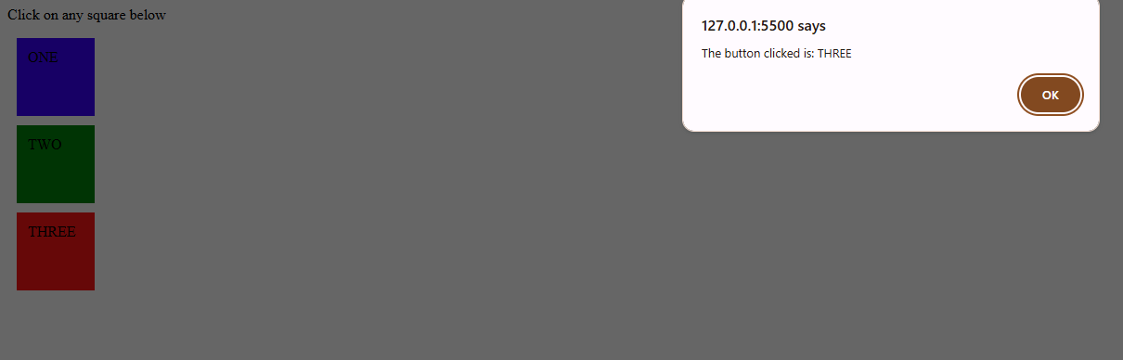

DOUBLE CLICK EVENT

CODE: (event.html)
<html>
<head>
<title>Double Click Event</title>
<script type="text/javascript" src="jquery-3.7.1.min.js"></script>
<script type="text/javascript" src="app.js"></script>
<link rel="stylesheet" type="text/css" href="style.css"/>
</head>

<body>
<p>Click on any square below to hide it</p>
<div class = "div" style="background-color: blue;">ONE</div>
<div class = "div" style="background-color: green;">TWO</div>
<div class = "div" style="background-color: red;">THREE</div>
</body>
</html>

CODE: (style.css)
.div{
margin:10px; padding:12px; border:2px; width:60px; height:60px;
}

CODE: (app.js)
$(document).ready(function(){
$("div").dblclick(function(){
$(this).hide();
});
});

OUTPUT:
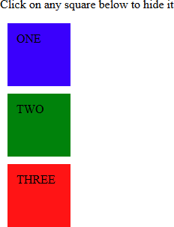
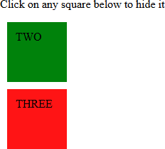

FADING EFFECT

CODE: (effect.html)
<html>
<head>
<title>Fading Effect</title>
<script type="text/javascript" src="jquery-3.7.1.min.js"></script>
<script type="text/javascript" src="app.js"></script>
<link rel="stylesheet" type="text/css" href="style.css"/>
</head>

<body>
<p>Click on any of the buttons</p>
<button id = "out"> FADE OUT</button>
<button id = "in"> FADE IN</button>
<div class = "pic"> <img src="sies.jpeg" alt="jQuery"/></div>
<div class = "log"></div>
</body>
</html>

CODE: (style.css)
p{
background-color: rgb(255, 238, 0); width:200px;
border:1px solid;
}

img{
height:150px; width:150px;
}

CODE: (app.js)
$(document).ready(function(){
$("#in").click(function(){
$(".pic").fadeIn('slow',function(){
$(".log").text("Fade In Tarnsition Complete");
});
});
$("#out").click(function(){
$(".pic").fadeOut('slow',function(){
$(".log").text("Fade OUT Tarnsition Complete");
});
});
});

OUTPUT:
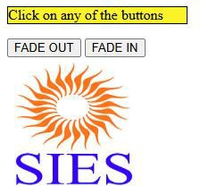
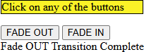


SLIDING EFFECT

CODE: (effect.html)
<html>
<head>
<title>Sliding Effect</title>
<script type="text/javascript" src="jquery-3.7.1.min.js"></script>
<script type="text/javascript" src="app.js"></script>
<link rel="stylesheet" type="text/css" href="style.css"/>
</head>

<body>
<p>Click on any of the buttons</p>
<button id = "up"> SLIDE UP</button>
<button id = "down"> SLIDE DOWN</button>
<div class = "pic"> <img src="sies.jpeg" alt="jQuery"/></div>
<div class = "log"></div>
</body>
</html>

CODE: (style.css)
p{
background-color: rgb(255, 238, 0); width:200px;
border:1px solid;
}

img{
height:150px; width:150px;
}

CODE: (app.js)
$(document).ready(function(){
$("#up").click(function(){
$(".pic").slideUp('slow',function(){
$(".log").text("Slide Up Transition Complete");
});
});
$("#down").click(function(){
$(".pic").slideDown('slow',function(){
$(".log").text("Slide Out Transition Complete");
});
});
});

OUTPUT:
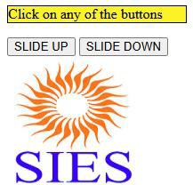
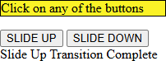
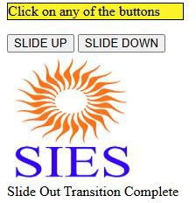

ANIMATION EFFECT

CODE: (effect.html)
<html>
<head>
<title>Animation Effect</title>
<script type="text/javascript" src="jquery-3.7.1.min.js"></script>
<script type="text/javascript" src="app.js"></script>
<link rel="stylesheet" type="text/css" href="style.css"/>
</head>

<body>
<button> START ANIMATION</button>
<div style="background-color: aqua; height: 100px;
width:100px; position:absolute;">ANIMATION EFFECT
</div>
</body>
</html>

CODE: (app.js)
$(document).ready(function(){
$("button").click(function()
{
$("div").animate({left:'250px'},"slow");
$("div").animate({height:'500px'},"slow");
$("div").animate({width:'300px'},"slow");
$("div").animate({fontSize:'50px'},"slow");
});
});

OUTPUT:
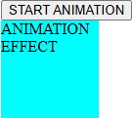
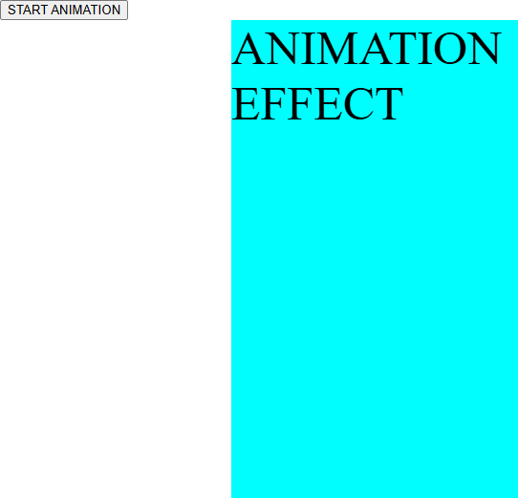

CHAINING EFFECT

CODE: (effect.html)
<html>
<head>
<title>Chaining Effect</title>
<script type="text/javascript" src="jquery-3.7.1.min.js"></script>
<script type="text/javascript" src="app.js"></script>
<link rel="stylesheet" type="text/css" href="style.css"/>
</head>

<body>
<p id="txt">THIS IS CHAINING IN JQUERY!!!</p>
<button>CLICK FOR EFFECTS</button>
</body>
</html>

CODE: (app.js)
$(document).ready(function(){
$("button").click(function()
{
$("#txt").css("color","red").slideUp(1000).slideDown(3000).fadeOut(3000).f adeIn(3000);
});
});

OUTPUT:
